**Circuit and System-I**

**LAB # 01**



**Spring 2022**

Submitted by: **Ali Asghar**

Registration No.: **21PWCSE2059**

Class Section: **C**

“On my honor, as student of University of Engineering and Technology, I have neither given nor received unauthorized assistance on this academic work.”

Student Signature: ______________

Submitted to:

**Engr. Faiz Ullah**

7 March 2022

Department of Computer Systems Engineering

University of Engineering and Technology, Peshawar

ASSESSMENT RUBRICS LAB # 01

Introduction to Basic Electrical Equipments

|  |  |  |  |  |
| --- | --- | --- | --- | --- |
| **LAB REPORT ASSESSMENT** | | | | |
| **Criteria** | **Excellent** | **Average** | **Nil** | **Marks Obtained** |
| 1. **Objectives of Lab** | All objectives of lab are properly covered  [Marks 1] | Objectives of lab are partially covered  [Marks 0.5] | Objectives of lab are not shown  [Marks 0] |  |
| 1. **Resistance, Voltage & Current** | Correct resistance, current and voltage statements and mathematical expressions are written. Circuit diagram shown is correct and properly labeled  [Marks 2] | Correct resistance, current and voltage statements or mathematical expression or circuit diagram is missing or circuit diagram is not properly labeled  [Marks 1] | Resistance, current and voltage statements, mathematical expression or circuit diagram are incorrect or missing.  [Marks 0] |  |
| 1. **Digital Multimeter** | Properly defined DMM and explained functionality in terms of voltage, current and resistance. Explain all steps required to calculate (voltage, current and resistance) measurement. Properly labeled DMM diagram is shown.  [Marks 2] | DMM and its functionality in terms of voltage, current and resistance are not properly explained. Steps required to calculate (voltage, current and resistance) measurement are partially shown. DMM diagram is shown but not labeled.  [Marks 1] | DMM and its functionality in terms of voltage, current and resistance are not explained. Steps required to calculate (voltage, current and resistance) measurement are not shown. DMM diagram is not shown  [Marks 0] |  |
| 1. **Power Supply** | Power supply is properly defined. Functionality and steps to provide source voltage to circuit are shown. Diagram is shown with all labels and available voltage values.  [Marks 1] | Power supply is not well defined. Functionality and steps to provide source voltage to circuit are not properly shown. Diagram is shown with no labels.  [Marks 0.5] | No steps for functionality of power supply are shown  [Marks 0] |  |
| 1. **Bread Board** | Breadboard is properly defined. Functionality and steps to design series parallel circuit are shown.  Open and short circuits are also defined. Diagrams are shown with all labels. [Marks 2] | Breadboard is partially defined. Functionality and steps to design series parallel circuit are not shown.  Information about open and short circuits are unsatisfactory.  Diagrams are shown with no labels. [Marks 1] | No steps for breadboard functionality are shown.  [Marks 0] |  |
| 1. **Observations & Calculations** | All experimental results are completely shown in form of table for varying voltages and resistances.  [Marks 2] | Experimental results are partially shown and some of the observations are missing  [Marks 1] | No experimental results are shown  [Marks 0] |  |
| Total Marks Obtained:__________    Instructor Signature: ______________________ | | | | |
|  | | | | |

**“INTRODUCTION TO BASIC ELECTRICAL LAB EQUIPMENT’S”**

**Objectives:**

1. To know about different basic electrical equipment and components.
2. To know about the working principle of Cathode Ray Oscilloscope.
3. To know about the function generator.
4. To learn how to use of these basic equipment.
5. To learn how to use of Digital Multimeter.
6. To know about the different nature of waves (sine, sawtooth, triangular waves etc).

**Apparatus:**

1. Digital Multimeter
2. Power Supply
3. Cathode Ray Oscilloscope
4. Connecting Wires
5. Function Generator
6. Breadboard

**THEORY:**

**Resistance:**

**“**Electrical resistance is a measure of the degree to which an object opposes the passage of an electric current. The SI unit of electrical resistance is the ohm.”

**Mathematically:**

**R = V/I**

**Current:**

**“**Current is a flow of electrical charge carriers, usually electrons or electron-deficient atoms. The common symbol for current is the uppercase letter I. The standard unit is the ampere’, symbolized by A.**”**

**Mathematically:**

**I = V/R**

**Voltage:**

**“**Voltage, also called *electromotive force*, is a quantitative expression of the potential difference in charge between two points in an electrical field.”

**Mathematically:**

**V = IR**

**Apparatus explanation:**

**CATHODE RAY OSCILLOSCOPE (CRO):**

The cathode ray oscilloscope (CRO) is a type of electrical instrument which is used for showing the measurement and analysis of waveforms and other electronic and electrical phenomena. It is an extremely quick X-Y plotter that shows the input signal versus another signal or versus time. The CROs are used to analyze the waveforms, transient, phenomena, and other time-varying quantities from an extremely low-frequency variety to the radio frequencies.

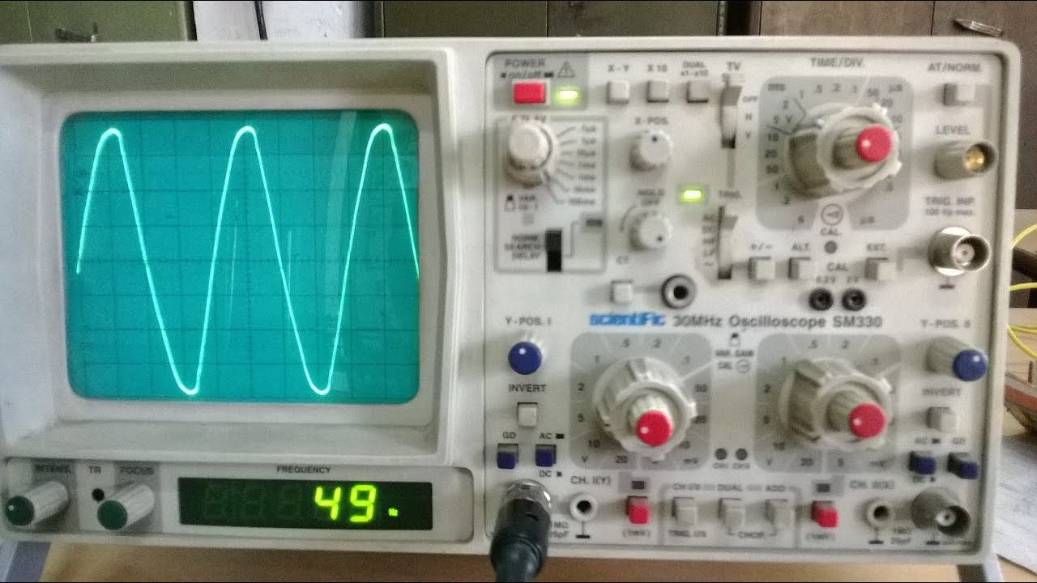

**CONSTRUCTION OF CRO:**

The building of CRO consists of the following:

* Cathode Ray Tube
* Electronic Gun Assembly
* Deflecting Plate
* Fluorescent Screen For CRT
* Glass Envelop

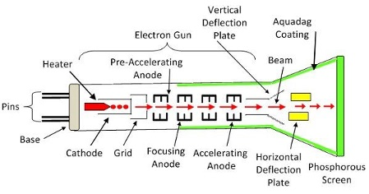

**OBSERVATIONS:**

|  |  |  |  |  |  |
| --- | --- | --- | --- | --- | --- |
| **S.NO.** | **AMPLITUDE(Volts)** | **FREQUENCY(Hz)** | **TIME PERIOD(s)** | **Frequency Calculated (Hz)** | **Error(%)** |
| 1 | 10 mV | 5 KHz | 0.2 m sec | 5 KHz | 0 % |
| 2 | 5V | 1.6 KHz | 0.2 m sec | 2.1 KHz | 31.25 % |
| 3 | 10 V | 1.2 KHz | 2.5 m sec | 1.1 KHz | 8.33 % |
| 4 | 2 mV | 1 kHz | 1 m sec | 1 KHz | 0 % |

**FUNCTION GENERATOR:**

A function generator is a specific form of signal generator that is able to generate waveforms with common shapes.

In particular it can be made to become a sine wave generator, square wave generator, and triangular wave generator.

A function generator may also be able to vary the characteristics of the waveforms, changing the length of the pulse, i-e the mark space ratio, or the ramps of the different edges of triangular or sawtooth waveforms, but it is only be able to create the waveforms that are built in to the function generator. It cannot be programmed to create additional waveforms - an arbitrary waveform generator, AWG is required for this.

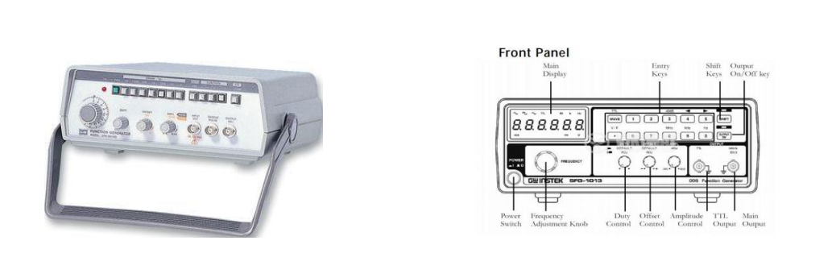

**DIFFERENT WAVEFORMS GENERATED BY FUNCTION GENERATOR:**

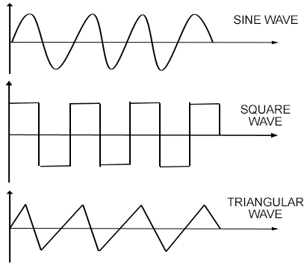

**DIGITAL MULTIMETER (DMM):**

**“**A digital multimeter or DMM is one of the most widely used pieces of test equipment today. DMMs are available very cheaply and these digital multimeters can provide very high degrees of accuracy when measuring the parameters within an electronics or electrical circuit. As a result, DMMs are one of the most indispensable pieces of test equipment available today.”

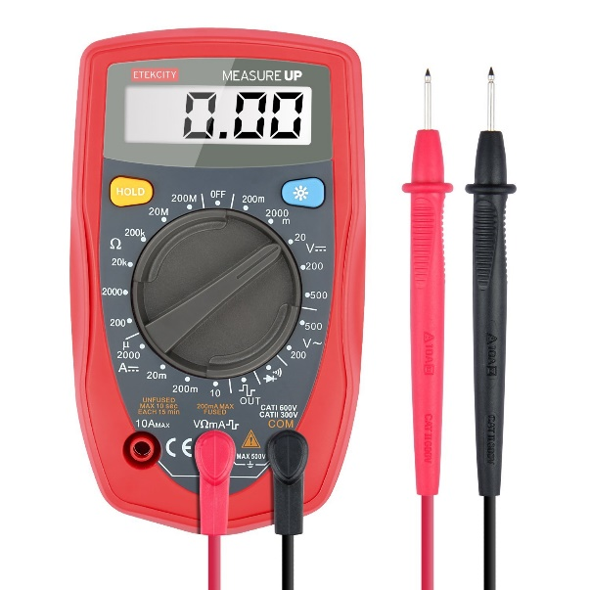

**Parts of a Multimeter:**

A multimeter mainly has two parts:

* Selection Knob
* Probes

**Selection Knob:**

The selection knob enables the user to set the multimeter to read different things such as Current, voltage and resistance. The user can also set the multimeter in different ranges.

**Probes:**

A multimeter has two probes. These probes are used to connect the multimeter in a circuit.

**POWER SUPPLY:**

A **power supply** is an electrical device that supplies electric power to an electrical load. The primary function of a power supply is to convert electric current from a source to the correct voltage, current, and frequency to power the load. As a result, power supplies are sometimes referred to as electric power converters.

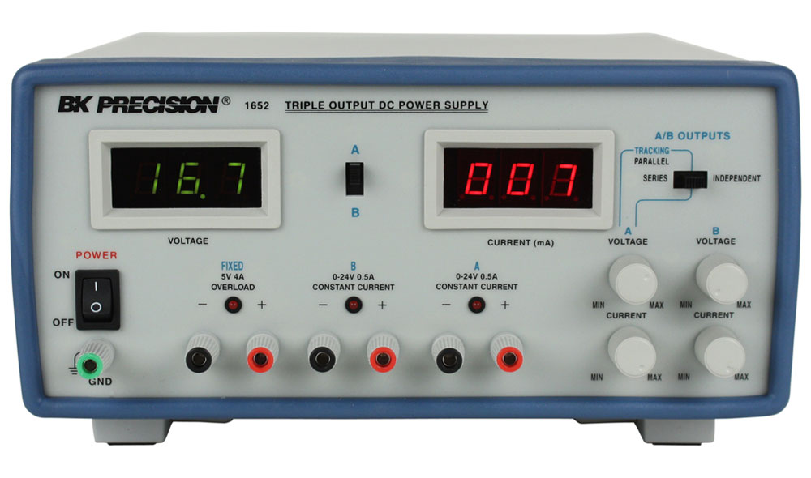

**TYPES OF POWER SUPPLY:**

* **AC POWER SUPPLY**
* **DC POWER SUPPLY**
* **HIGH VOLTAGE POWER SUPPLY**
* **BIPOLAR POWER SUPPLY**

SPECIFICATION OF POWER SUPPLY:

The suitability of a particular power supply for an application is determined by various attributes of the power supply, which are typically listed in the power supply's *specification*. Commonly specified attributes for a power supply include:

* Input voltage type (AC or DC) and range
* Efficiency of power conversion
* The amount of voltage and current it can supply to its load
* How stable its output voltage or current is under varying line and load conditions
* How long it can supply energy without refueling or recharging (applies to power supplies that employ portable energy sources)

**BREAD BOARD:**

A **breadboard** is a construction base for prototyping of electronics.

**Connections inside Bread Board:**

Inside in the bread board the middle part are connected vertically. The upper two lines are connected parallel.

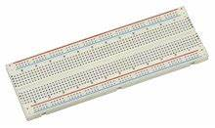

.

**Experiment:**

To find the voltage and current of power supply using Digital Multimeter.

**Procedure:**

1. Connect the knobs to the power supply and note the reading given on the power supply.

2. Connect the multimeter with the knobs, negative with the negative one and positive with the positive one.

3. Set the multimeter at the minimum to measure the voltage and then turn ON the power supply. 4. Note the readings from the screen of the multimeter.

5. Find the current using the formula = 𝑣 /𝑟.

6. Compare the readings taken from the multimeter with the actual reading of the power and find the percentage error.

**Observations:**

|  |  |  |  |
| --- | --- | --- | --- |
| **S.No.** | **Power Supply(V)** | **Digital Multimeter(V)** | **Error%** |
| 1 | 5V | 5.18 | 3.6% |
| 2 | 15V | 15.15 | 1% |
| 3 | 5 V | 4.89 V | 2.2% |
| 4 | 15V | 15.21 V | 1.4% |
| 5 | 15V | 15.12 V | 0.8% |